Unit 3 Information Exchange

**Corey Crooks**

**Purdue University Global**

**IT332 – Principles of Information Systems Architecture**

**Jonathan Abramson**

**July 26th, 2023**

**Essay Content**

Hearts play a vital role in human biology. They help regulate bodily functions, and provide an important rhythm that several mechanisms in human physiology uses in order to function optimally. This is much the same at the “heart” of a computer. In each computer system, a Central Processing Unit can be found. This CPU is in charge of a number of critical functions. At the core theory behind each CPU on the market today, there are a number of modules (The University of Rhode Island, n.d.). Firstly and arguably most importantly, there is the CPU clock. This helps the computer keep on schedule, and synch various behaviors for optimal execution. There are also registers in charge of scheduling, executing, and accumulating data being processed by the CPU. This data is stored in exceedingly fast and non-volatile memory called Static Random-Access Memory (SRAM) and make up the CPU’s cache. When the CPU has processed data from SRAM, it can move it to a computer’s high-capacity volatile storage just simply called “Random Access Memory”, or RAM via instructions, and addresses to store the data. Essentially, when a program is operating all that is happening is that the CPU goes through cycles determined by the CPU clock mentioned earlier through a series of steps until execution is completed.

This execution can have a number of different outputs, but is usually used to manipulate or move data on the system. This can be done through the computer’s Bus. The bus is a data transmission method utilizing several lanes as integrated into a computer’s motherboard (North Carolina State University, 2023). This bus comes in a number of different setups, but commonly uses either Parallel or Serial Bus setups. Serial Bus setups use a single bus lane to transmit data bit by bit. Parallel busses speed this transaction by using multiple lanes to transmit data. This operation can and has been used to store data via SATA connections on your computer to put data from volatile RAM into stable storage. But another method of communication by bus can be done with peripheral devices from the computer’s USB port. Interaction with external devices triggers a cascade of effects throughout the computer’s system. This interaction is labeled as Input. For instance, pressing a key on a keyboard connected to a computer can have that input communicated to the computer for the CPU to process, and the system to display as a visual change for the end user to recognize. Typing a word document for an IT332 assignment may seem simple enough, as it is just putting letters on the screen; but instead, it is actually quite a complicated process. Data inputs have to be processed by the computer system, and a number of different modules of that system must recognize and interact with that specific change in order to display even just one single character in a font specified. There are billions of operations happening at any moment in a modern computerized system that would be impossible for a human to track exactly what is happening and how. Endless loops combined with the already blazing fast speeds of modern computer components make a jaw-dropping display of information exchanged near flawlessly between systems. It would take a human an entire lifetime to follow every step that a modern CPU can execute in a minute (Indiana University Information Technology Services, 2023).

But even with the raw speed of modern components, more has to be done to ensure computers are up to the challenges presented by modern applications. Multiprocessing plays a large role in optimizing the instruction sets for optimal compute times. Multiprocessing is a discipline of programming that ensures multiple functions or methods may run at the same time utilizing similar spaces (Berkeley University of California, 2020). Essentially, it is the best attempt a CPU has to get through multiple large tasks all at once. If certain processes of a given application may be run in parallel, then it would be much faster to execute those tasks at the same time rather than wait for each task to finish, and execute them all sequentially. This is the theory at work in Multiprocessing as specified by the programmer that implements the feature in their programs.

In a given computerized system, there are a number of factors at work to ensure the system is running both optimally and functionally. A CPU executes instructions sets with program cycles, contains information in a cache, and puts that information in storage via a bus. These systems all contain complex programming to ensure all the billions of moving parts to your software can run not only without error, but with as much efficacy as the system can allow. With these technologies in place, the power in even the small devices in pockets today is unimaginable to be computed by humans alone.

**Computer Diagram**

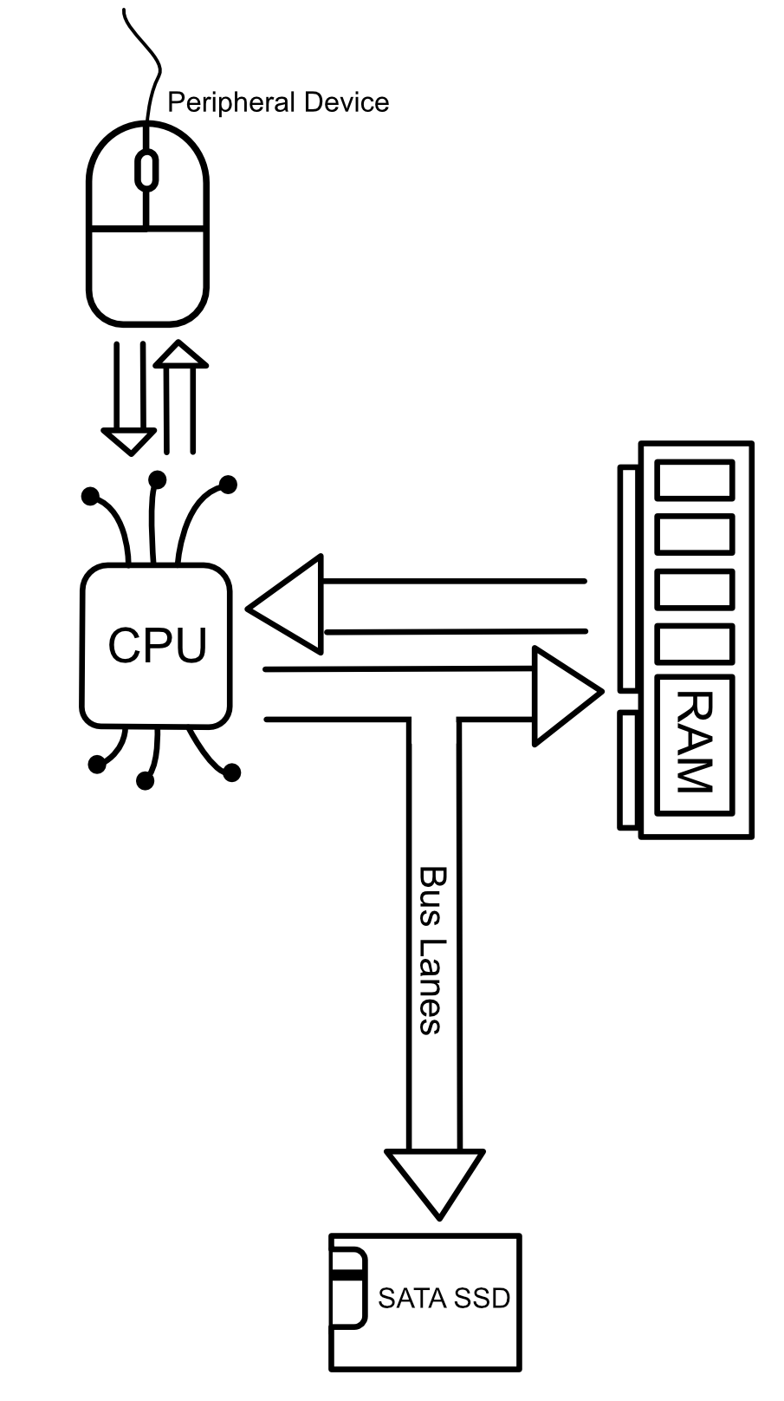

# **References**

Berkeley University of California. (2020). *Multiprocessing*. Retrieved from berkeley.edu: https://pythonnumericalmethods.berkeley.edu/notebooks/chapter13.02-Multiprocessing.html

Indiana University Information Technology Services. (2023, May 05). *Apeq*. Retrieved from kb.iu.edu: https://kb.iu.edu/d/apeq

North Carolina State University. (2023). *System Bus*. Retrieved from ncsu.edu: https://e115.engr.ncsu.edu/hardware/system-bus/

The University of Rhode Island. (n.d.). *How Computers Work: The CPU and Memory*. Retrieved from cs.uri.edu: https://homepage.cs.uri.edu/faculty/wolfe/book/Readings/Reading04.htm